Required Practical Activity:
Density 2

Note:
This resource is designed as a review of the required practical activity, covering all possible skills that could be developed through the investigation. This resource can be adapted to suit the needs of your class, depending on which skills your class need support with.

In this investigation we will use the displacement method and a balance to determine the density of an irregularly shaped solid.

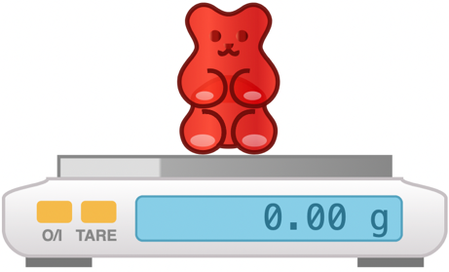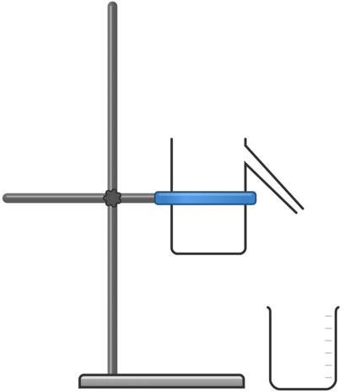

Method:

- Use the digital mass balance to measure the mass of one of the irregular shaped objects. Record this mass in your table.
- Secure the displacement can in the clamp stand so it is well-supported, and the spout is just higher than the top of your measuring cylinder. Select a measuring cylinder of an appropriate size for the object you will be measuring.
- Place an empty beaker beneath the spout of the displacement can. Carefully fill the displacement can with water until water leaks from the spout into the beaker. Wait until the spout stops dripping before proceeding to the next step.
- Remove the beaker and place your measuring cylinder beneath the spout.
- Slowly and carefully lower the irregular shaped object into the displacement can. You may wish to use a short length of cotton to do this to avoid having to drop the object and cause a splash.
- Measure and record the volume of water displaced from the can to the measuring cylinder. This will be equal to the volume of the object.
- Calculate and record the density of the irregular shaped object.

- Equipment:
- What measurements need to be taken in this investigation?
- What is the most suitable piece of apparatus to take measurements with? Why?
- Identify any hazards in this investigation.
- Why is it important that the balance is properly zeroed before weighing your object?

- Why is it important to lower the irregular shaped object into the displacement can slowly and gently?
- What units will we use for measuring the volume of displaced water?
- What is the difference between weight and mass?
- What is the relationship between 1 cm³ and 1 ml?
- What is the equation to calculate density?
- What will be our units for density if we measure mass in grams (g) and length in centimetres (cm)?
- What are the S.I. units for density?

- Results
Irregular shaped object | Volume (cm³) | Mass  (g) | Density  (g/cm³) | Density  (kg/m³)
Metal bolt | 11.0 | 93.0 | 8.5 | 8455
Plastic toy | 27.0 | 29.0 | 1.1 | 1074

- Explain why it is appropriate to round measurements taken with a ruler to the nearest millimetre.
- Which object had the highest density?
- Which object had the lowest density?

